Assignment

1. Create 1 ec2 instance.

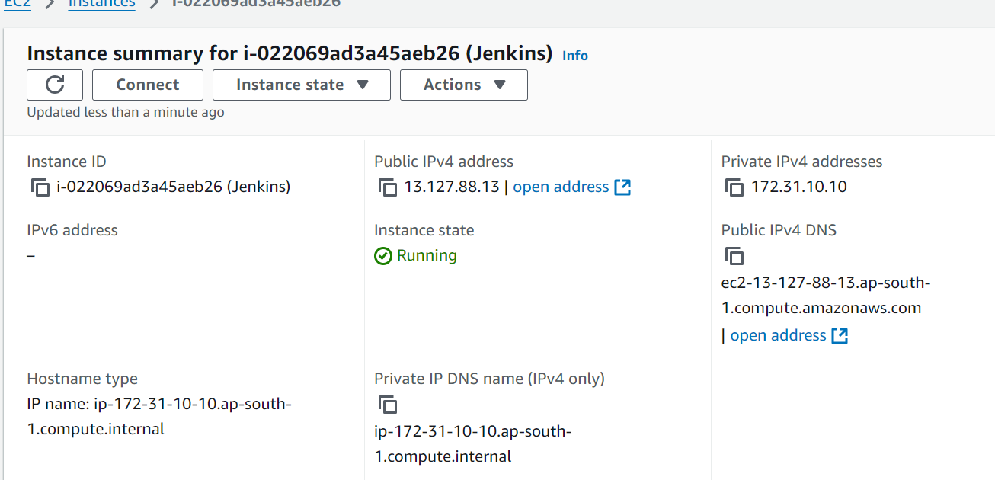

1. Install Jenkins as a war application
2. amazon-linux-extras install java-openjdk11 -y



1. mkdir servers

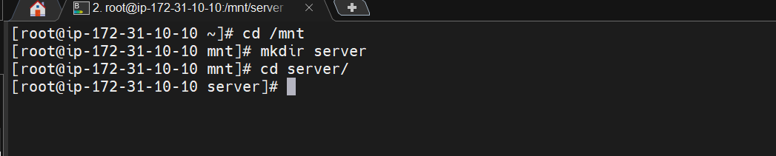

1. install tomcat wget <https://dlcdn.apache.org/tomcat/tomcat-9/v9.0.96/bin/apache-tomcat-9.0.96.zip>

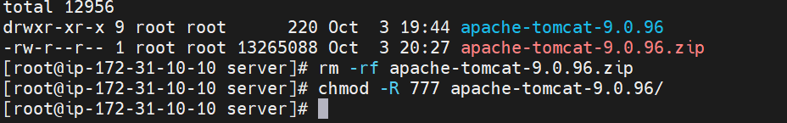

1. install Jenkins wget <https://get.jenkins.io/war-stable/2.414.3/jenkins.war>

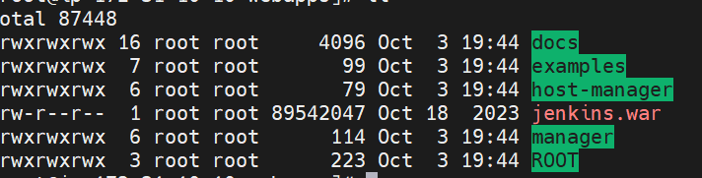

1. then go to bin and start tomcat run ./startup.sh

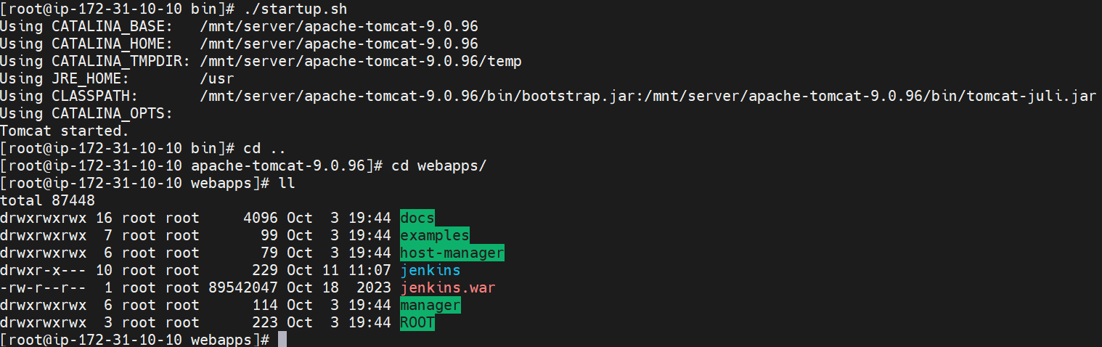

1. hit IP in url check Output

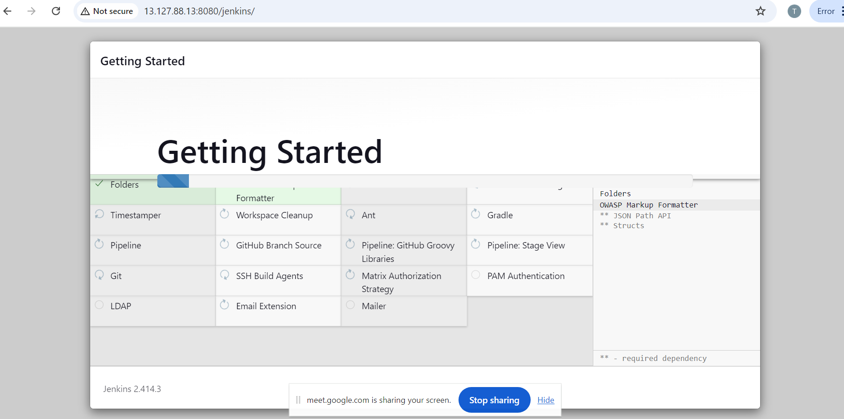

1. Install blueocean plugin and go through plugins on Jenkin
2. Go to manage Jenkins 🡪 Plugins 🡪 install blueocean

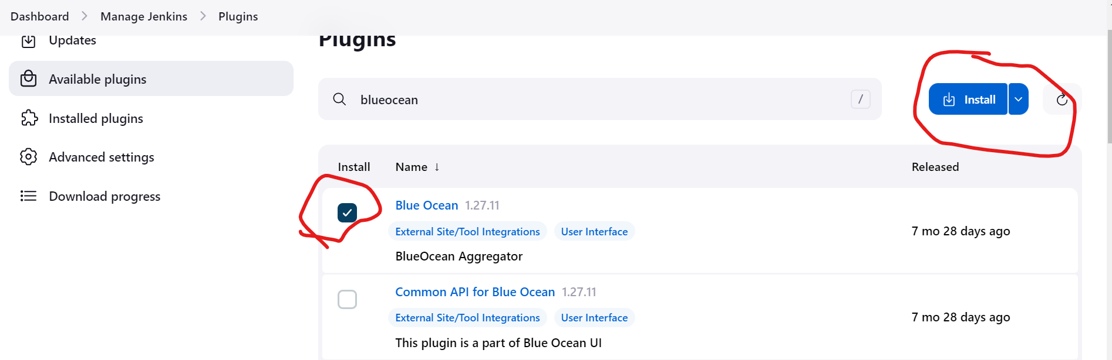

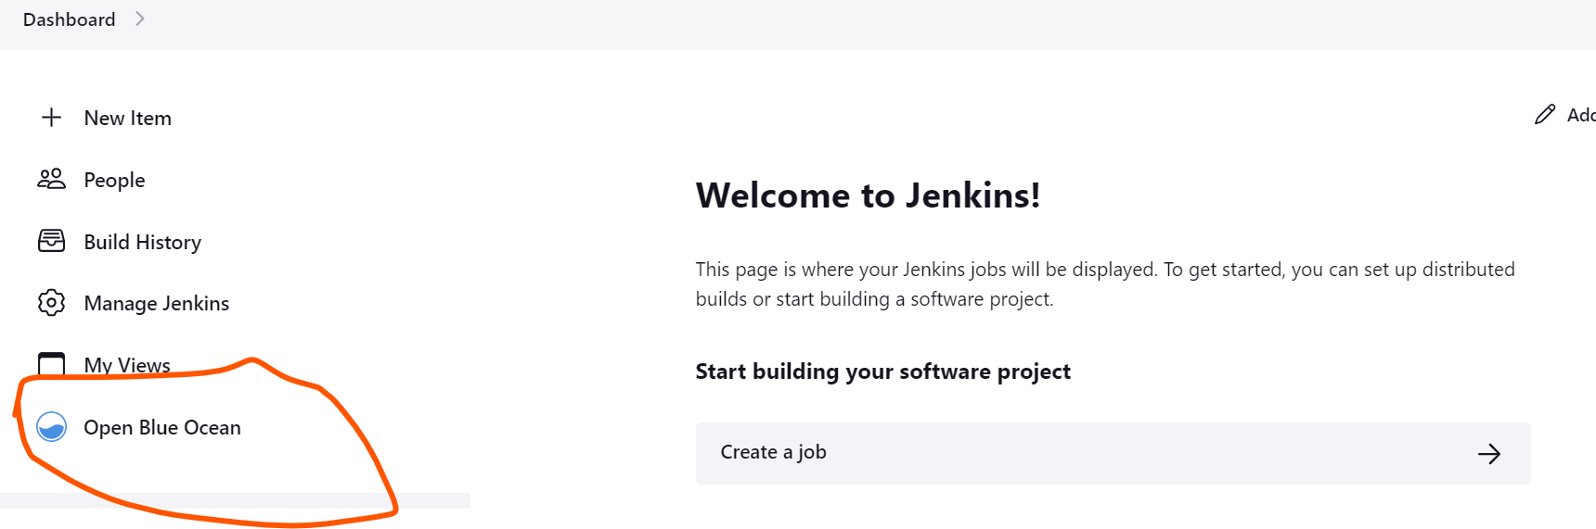

1. **sequential Jobs**
2. create 3 different jobs

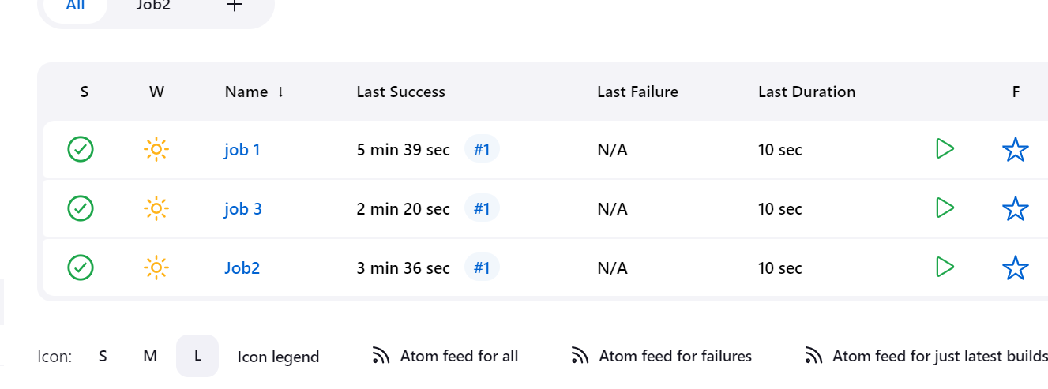

1. after go to job 1 and configure below setting

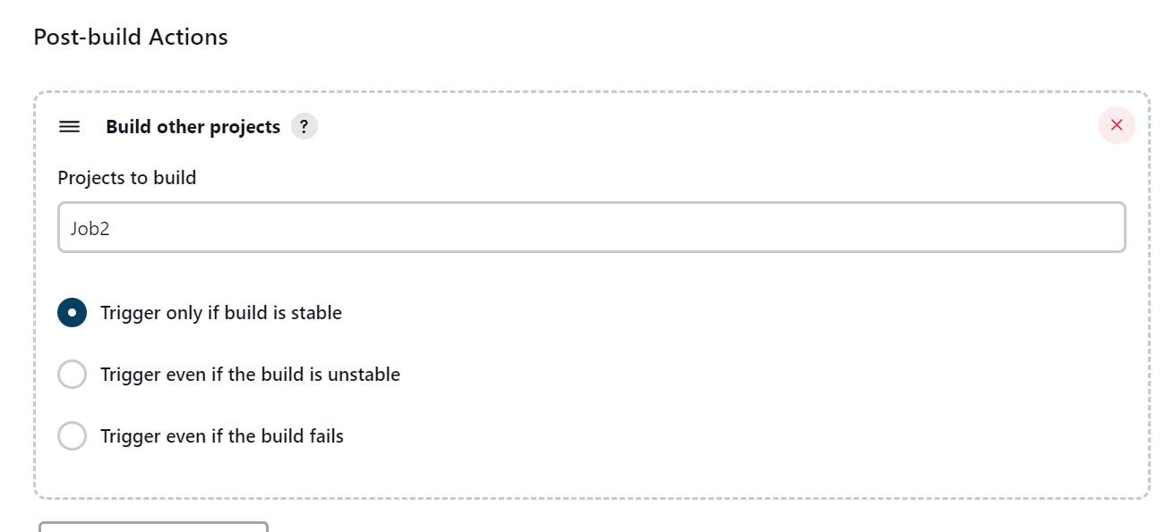

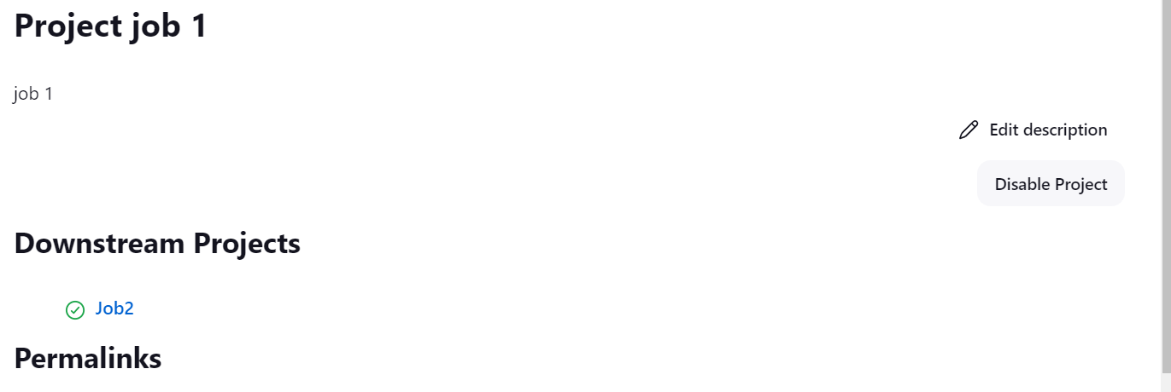

1. same as Job 2

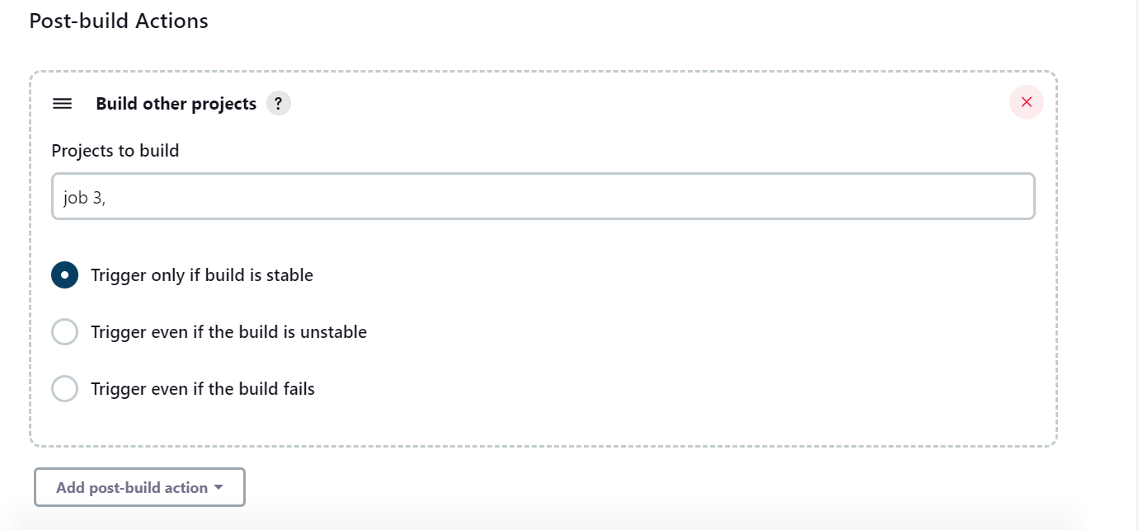

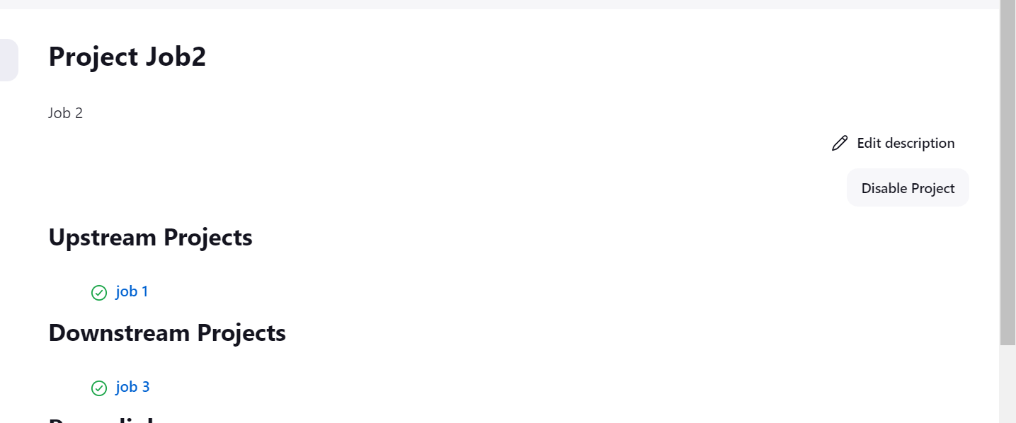

1. then build the project.

Started by user [Tushar Chavan](http://13.127.88.13:8080/jenkins/user/412tushar)

Running as SYSTEM

Building in workspace /root/.jenkins/workspace/job 1

[job 1] $ /bin/sh -xe /mnt/server/apache-tomcat-9.0.96/temp/jenkins2823378693210130366.sh

+ sleep 10

+ echo ' This is job1 '

This is job1

Triggering a new build of [Job2](http://13.127.88.13:8080/jenkins/job/Job2/)

Finished: SUCCESS

Started by upstream project "[job 1](http://13.127.88.13:8080/jenkins/job/job%201/)" build number [2](http://13.127.88.13:8080/jenkins/job/job%201/2)

originally caused by:

Started by user [Tushar Chavan](http://13.127.88.13:8080/jenkins/user/412tushar)

Running as SYSTEM

Building in workspace /root/.jenkins/workspace/Job2

[Job2] $ /bin/sh -xe /mnt/server/apache-tomcat-9.0.96/temp/jenkins288119406230129807.sh

+ sleep 10

Triggering a new build of [job 3](http://13.127.88.13:8080/jenkins/job/job%203/)

Finished: SUCCESS

Started by upstream project "[Job2](http://13.127.88.13:8080/jenkins/job/Job2/)" build number [7](http://13.127.88.13:8080/jenkins/job/Job2/7)

originally caused by:

Started by upstream project "[job 1](http://13.127.88.13:8080/jenkins/job/job%201/)" build number [7](http://13.127.88.13:8080/jenkins/job/job%201/7)

originally caused by:

Started by user [Tushar Chavan](http://13.127.88.13:8080/jenkins/user/412tushar)

Running as SYSTEM

Building in workspace /root/.jenkins/workspace/job 3

[job 3] $ /bin/sh -xe /mnt/server/apache-tomcat-9.0.96/temp/jenkins12121556709168403931.sh

+ sleep 10

+ echo ' This is Job3'

This is Job3

Finished: SUCCESS

1. **parallel Jobs**
2. create 3 jobs

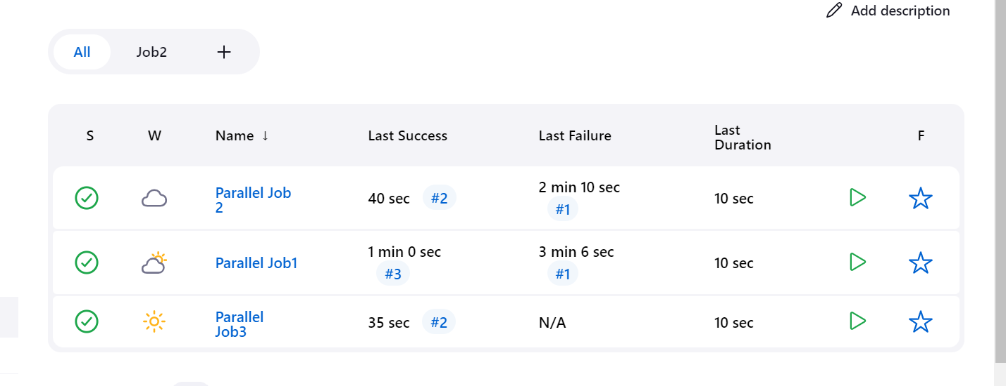

1. after go to job 1 and configure below setting

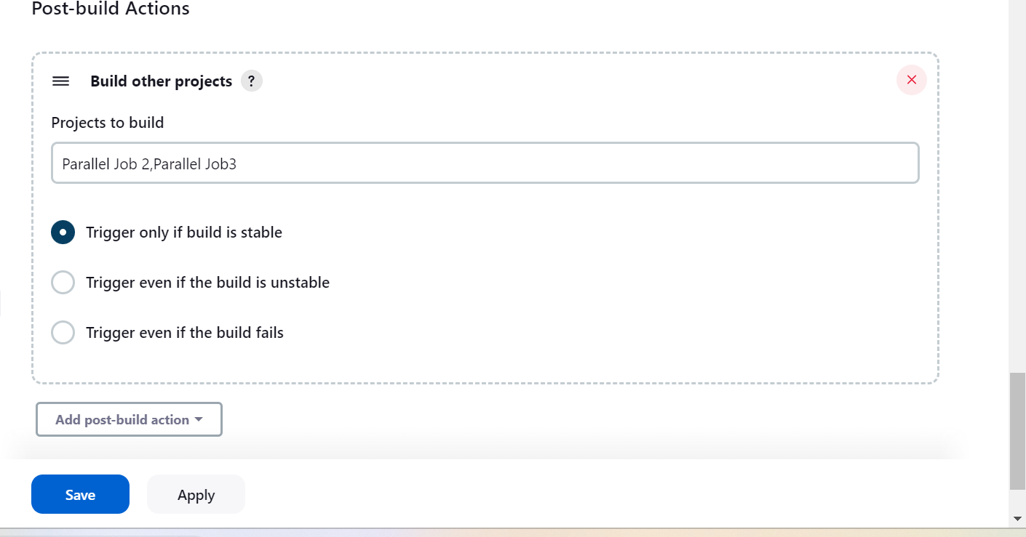

1. after that run Job 1 and see output

Started by user [Tushar Chavan](http://13.127.88.13:8080/jenkins/user/412tushar)

Running as SYSTEM

Building in workspace /root/.jenkins/workspace/Parallel Job1

[Parallel Job1] $ /bin/sh -xe /mnt/server/apache-tomcat-9.0.96/temp/jenkins4064484221001909963.sh

+ echo ' Thanks for coming'

Thanks for coming

+ sleep 10

Triggering a new build of [Parallel Job 2](http://13.127.88.13:8080/jenkins/job/Parallel%20Job%202/)

Triggering a new build of [Parallel Job3](http://13.127.88.13:8080/jenkins/job/Parallel%20Job3/)

Finished: SUCCESS

Started by upstream project "[Parallel Job1](http://13.127.88.13:8080/jenkins/job/Parallel%20Job1/)" build number [3](http://13.127.88.13:8080/jenkins/job/Parallel%20Job1/3)

originally caused by:

Started by user [Tushar Chavan](http://13.127.88.13:8080/jenkins/user/412tushar)

Running as SYSTEM

Building in workspace /root/.jenkins/workspace/Parallel Job 2

[Parallel Job 2] $ /bin/sh -xe /mnt/server/apache-tomcat-9.0.96/temp/jenkins12063026968992438125.sh

+ echo ' This coming from Job1 '

This coming from Job1

+ sleep 10

Finished: SUCCESS

Started by upstream project "[Parallel Job1](http://13.127.88.13:8080/jenkins/job/Parallel%20Job1/)" build number [3](http://13.127.88.13:8080/jenkins/job/Parallel%20Job1/3)

originally caused by:

Started by user [Tushar Chavan](http://13.127.88.13:8080/jenkins/user/412tushar)

Running as SYSTEM

Building in workspace /root/.jenkins/workspace/Parallel Job3

[Parallel Job3] $ /bin/sh -xe /mnt/server/apache-tomcat-9.0.96/temp/jenkins11606146468507029299.sh

+ echo ' Thanks for Parallel job '

Thanks for Parallel job

+ sleep 10

Finished: SUCCES

1. **Build periodically**
2. Create Job1

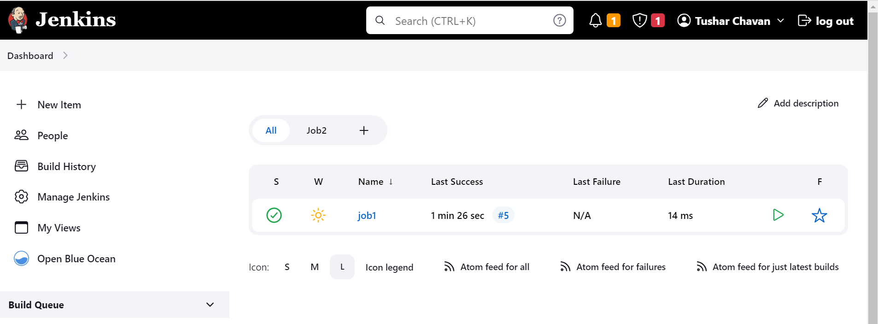

1. Go to configure 🡪 Build trigger 🡪 give specific time when you want job run.

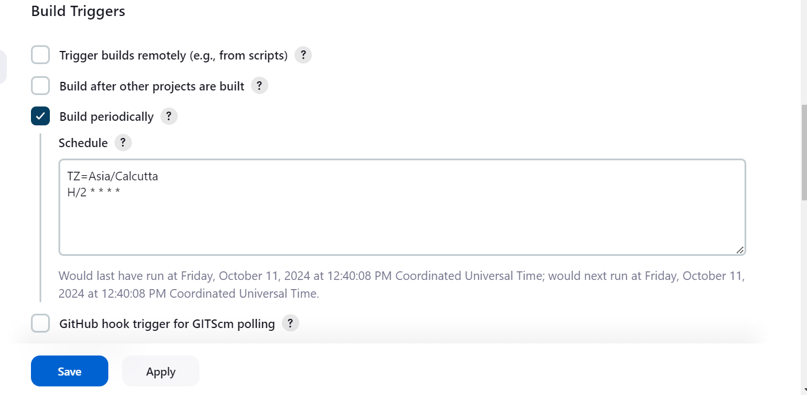

1. Run job 1 and check after 2 min job run automatically run or not ?

